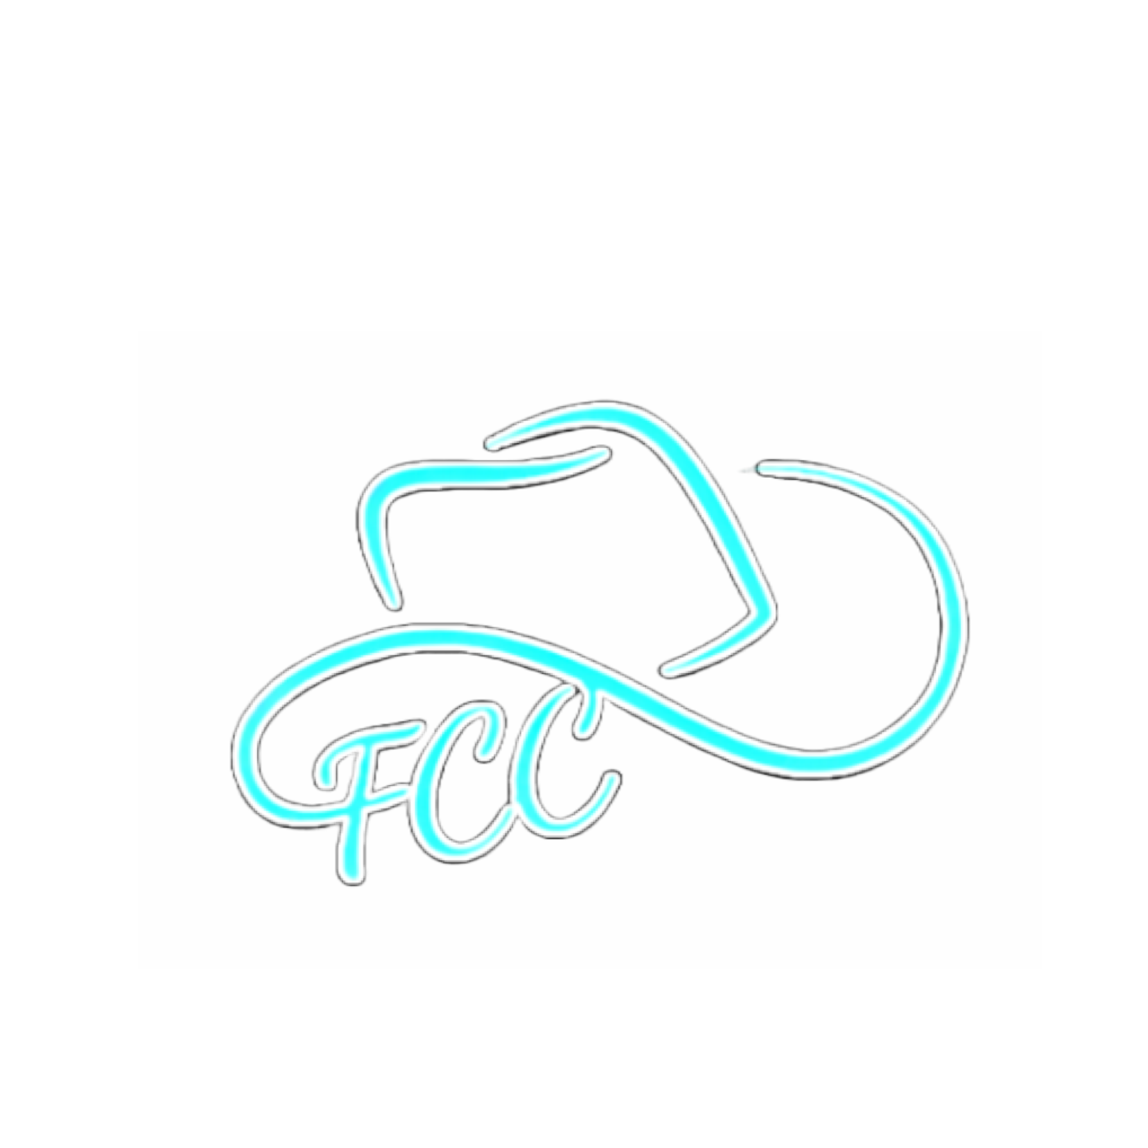FCCRS SPONSORSHIP PACKAGE

The Future Cowboys and Cowgirls Rodeo Society (FCCRS) is a 501(c)(3) non-profit youth organization dedicated to promoting family fun, sportsmanship, and the love of rodeo. Our mission is to teach, mentor, and encourage young athletes in the sport of rodeo while developing character, horsemanship, and lifelong friendships.
Founded in 1999 in Okotoks, Alberta, by a group of passionate rodeo enthusiasts, FCCRS has grown into a vibrant community supporting youth rodeo across Southern Alberta.
Our athletes are 17 years and younger, competing in age divisions: Lead Line, 7 & Under, 8–10, 11–13, and 14–17. Each rodeo features the following exciting events: barrel racing, pole bending, goat untying/tying, roping/team roping, and steer riding.
The Winter Rodeo Series runs from November through February, with contestants accumulating points in each event. Our season concludes with a formal Banquet, where champions in each event are recognized and awarded prizes.
By sponsoring FCCRS, your organization has the unique opportunity to support the next generation of rodeo stars while gaining visibility throughout the Southern Alberta rodeo community. Your brand will be showcased at all rodeos and the Banquet, and you’ll have the chance to meet our athletes, families, and board members in person.
We sincerely thank you for considering a partnership with FCCRS and look forward to introducing you to a remarkable group of hard-working young cowboys and cowgirls.

Sponsorship Levels
Major Sponsor – $1,000
- Company name engraved on two buckles of your choice
- Two complimentary Banquet tickets; present the buckle and prizes to the age groups of your choice
- Company name and logo featured as a Major Sponsor on the FCCRS website and social media
- Full-page ad in the FCCRS Finals and Banquet program
- Company banner or sign displayed at the Finals and throughout the 2025/2026 rodeo season (banner provided by sponsor)
- Company flag included in the FCCRS Finals grand entry (flag provided by sponsor)
- Thank-you photo featuring all FCCRS Finalists
Gold Sponsor – $500
- Company name engraved on a buckle of your choice
- “Feature Sponsor” for two events of your choice (any age group) at all rodeos
- One complimentary Banquet ticket; present the buckle and prizes
- Company name and logo as a Gold Sponsor on FCCRS website and social media
- Half-page ad in the FCCRS Finals and Banquet program
- Company banner or sign displayed at the Finals and throughout the 2025/2026 season
- Thank-you photo featuring all FCCRS Finalists
Silver Sponsor – $250
- Company name engraved on a buckle of your choice
- “Feature Sponsor” for one event of your choice (any age group) at all rodeos
- Company name and logo as a Silver Sponsor on FCCRS website and social media
- Company logo in the FCCRS Finals and Banquet program
- Company banner or sign displayed at the Finals and throughout the 2025/2026 season
- Complimentary photo featuring all FCCRS Finalists
- Opportunity to present your buckle at the Banquet
Supporting Sponsor – Any Amount
- Recognition of your support throughout the Winter Rodeo Series
- Company name and logo on FCCRS website and social media
- Company logo in the FCCRS Finals and Banquet program
- Complimentary photo featuring all FCCRS Finalists
- Opportunity to present your buckle at the Banquet

Sponsorship Form Please submit this form via email to info@futurecowboysandcowgirls.com to confirm your sponsorship.

Company/Sponsor Name: _____________________________________________________________________________________________________________
Address: __________________________________________________________________________________________________________________________
Contact Name: ______________________________________________________ Contact Number: _________________________________________________

Sponsorship Level/Amount: ___________________________
For Major & Gold Sponsors – Top 3 Age Group Preferences:

Signature: ______________________________________________________________________
Date: __________________________________________________________________________
Your sponsorship is not confirmed until this form is returned to info@futurecowboysandcowgirls.com

